**DBMS Lab Assignment 7**

**Neeti Kurulkar**

**Concept of Triggers**

**Queries:**

1. **Create Tables**

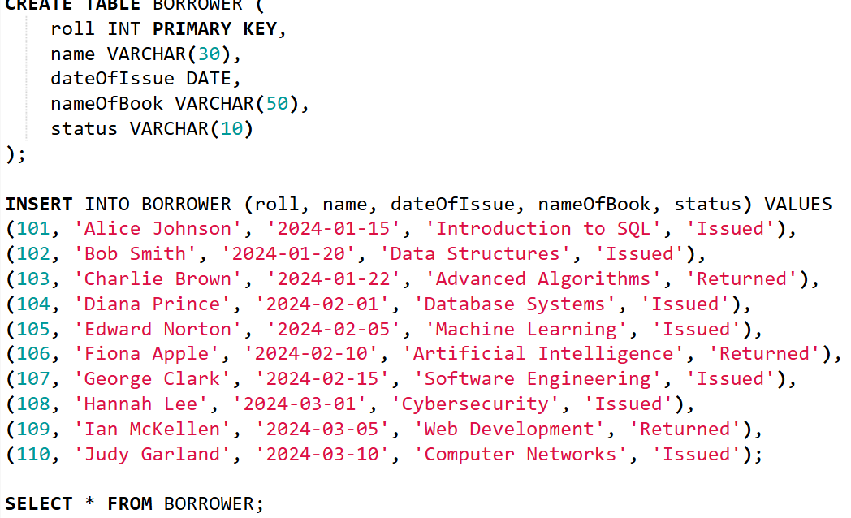

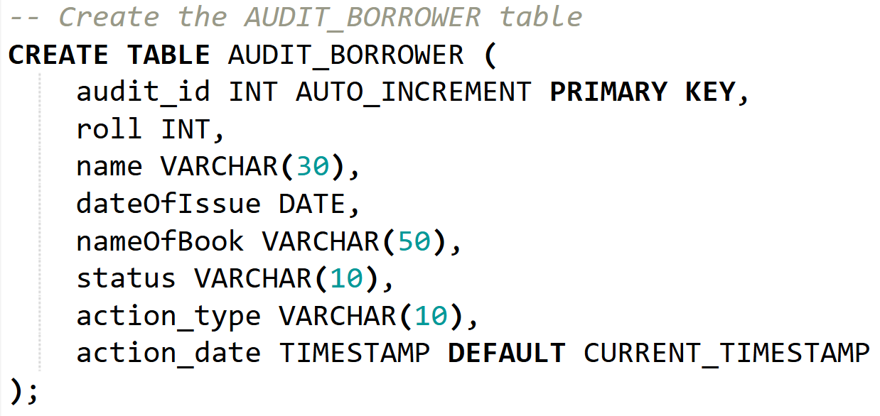

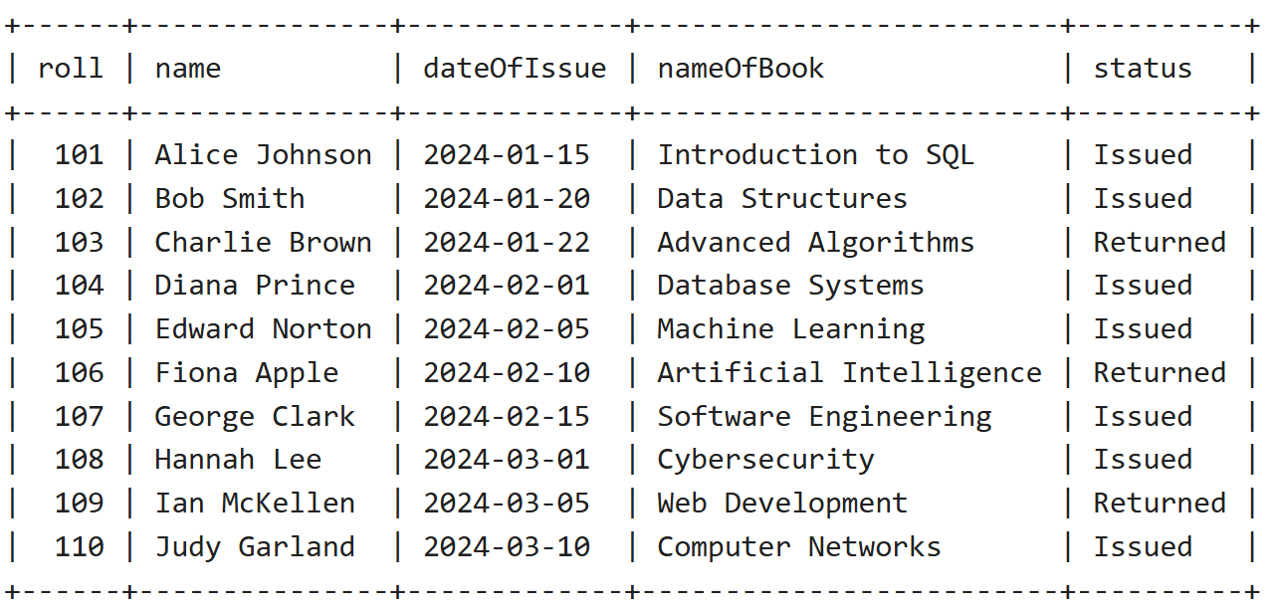

1. **Create Trigger for ‘Before Update’**

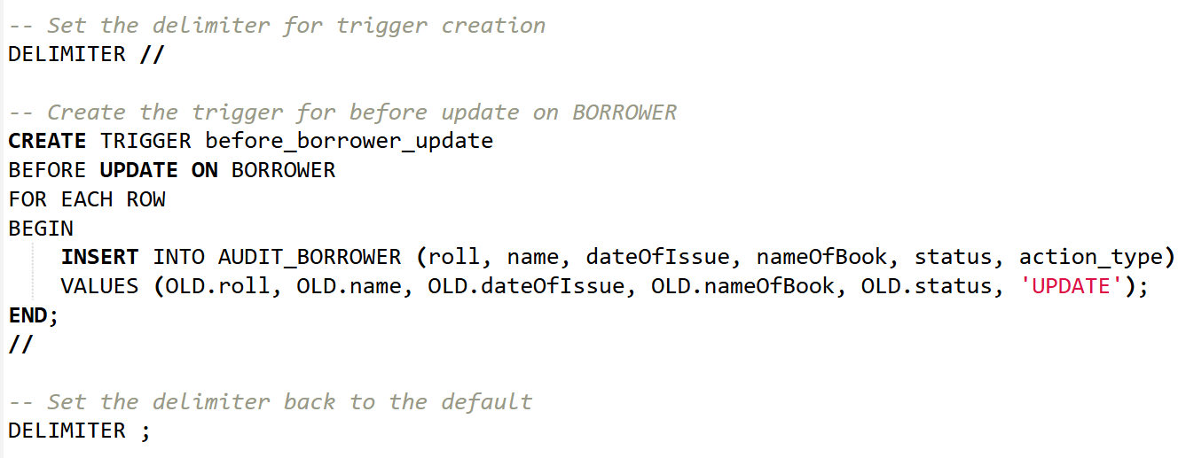

1. **Create Trigger for ‘Before Delete’**

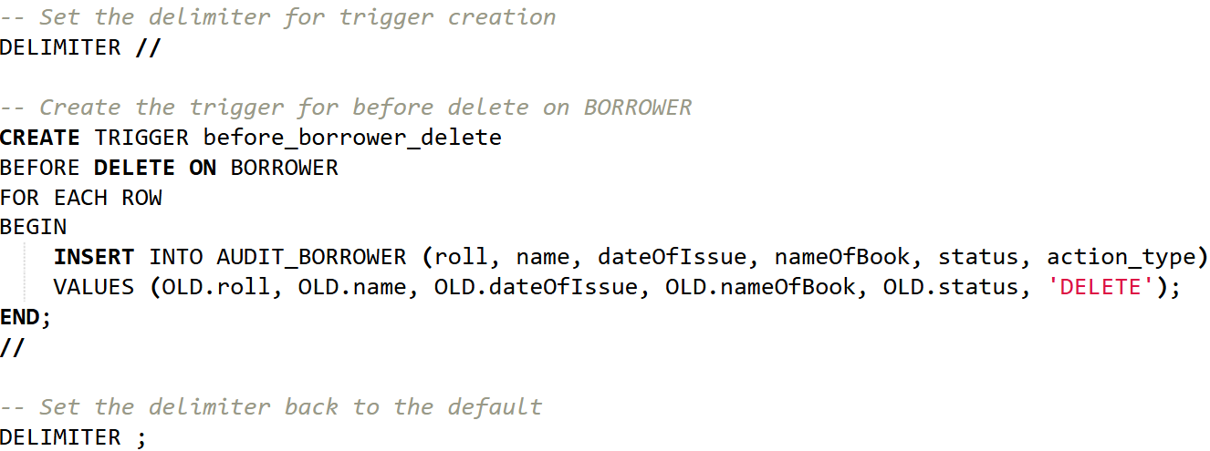

1. **Update and Delete records in ‘Borrower’ table**

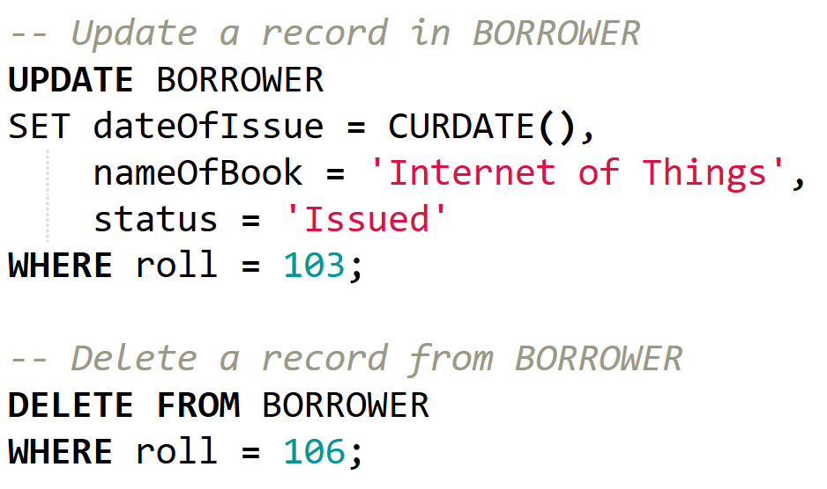

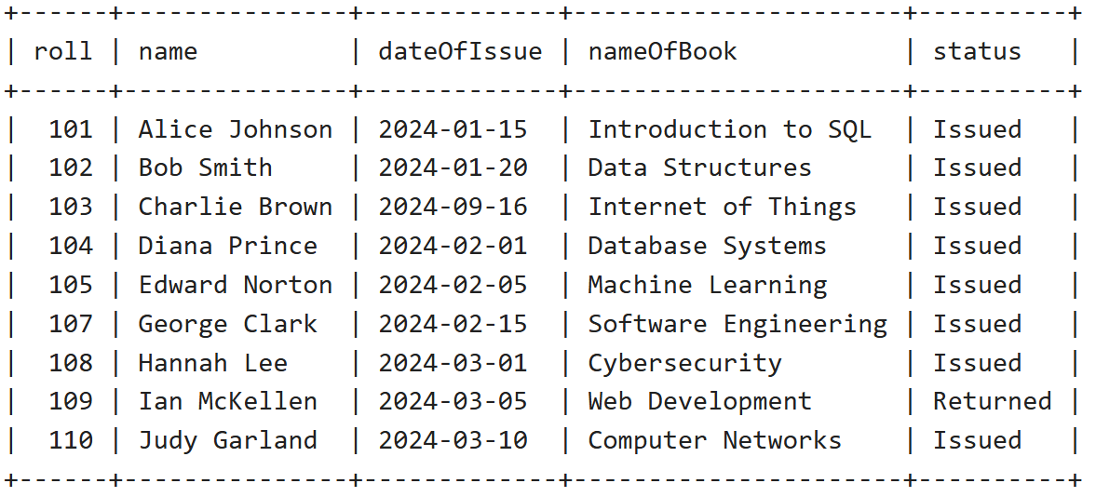

1. **Check Audit Table**



